ONE-STOP ONLINE SHOP

June 20, 2016

MEMBERS:

Bulos, Joreyna R.

Decena, Jeanne Kevin T.

Payas, Adrian Mark M.

BACKGROUND:

> Our one-stop online shop provides a convenient and easy shopping to our customers at affordable prices. Users get to decide on how much they would like to sell their items. There is no limit on how many items each user gets to sell, as long as they're in accordance to the rules. The ability to rate a user after a transaction is present too, so that other users know the reputation of the user on criteria such as quality of items being sold, clarity and uniqueness. All customers are welcomed but users below 18 years old need parental consent to use the site since most items may be too vague for them.

The site also contains a FAQ page to guide customers on how to sell products, tips, guidelines on buying products and strategies. Although most questions are answered in the FAQ page, we welcome customers submitting a support ticket that will be emailed to our staff for other concerns not listed on the page. We also welcome feedback on our service and suggestions on how to improve them. The site also features occasional promos from time-to-time that will encourage customers to sell their products and gain incentives such as increased exposure, featured seller etc.

MISSION:

* to let our customers buy and sell products ranging from games, clothes etc. in affordable prices.

GOALS:

* to satisfy customers with ease.
* to provide a one-stop shop to customers for buying and selling.
* to provide a convenient shopping destination for all customers.

ASSESSING USER SATISFACTION:

* ability to rate user when a transaction has been made.
* a "Contact Us" form for sending feedbacks, suggestions and problems to the staff.
* an occasional survey that focuses on suggestions and how they enjoy using our services.

SITE REQUIREMENTS:

* the site is accessible by all modern browsers (Firefox, Chrome, IE, Opera, Safari etc.)
* should run on modern OS from XP until the most recent ones (Windows 8, 9, 10 etc.)
* may require Adobe Flash for certain media elements.

PAGES:

1. HOME (**index.html**)

> the main homepage of the site. Includes all categories where the users can browse items from that category. A jumbotron for featured sellers (for example) and other ads with high views. An advertisement space is shown on the right side.

1. FAQ (**faq.html**)

> “Frequently Asked Questions”. Users who have inquiries on how to use the site or its services can go here. They can use the search box if they couldn’t find what they’re looking for. If the concern couldn’t be answered or is not found within the questions, then they can send a support ticket through a “Contact Us” form, which will be gladly answered by the staff.

1. ABOUT US (**about.html**)

> includes the background, mission, goals of the site as well as the “meet the team” section. It can also include other statistics, such as number of ads sold since site inception.

1. ARCHIVES (**archives.html**)

> records of past promos and other site-related posts that are not visible on the site and are only used for historical purposes are found on this page.

1. SITEMAP (**sitemap.html**)

> lists down each pages’ links that will go to a different section of the site.

1. TERMS OF USE (**termsofuse.html**)

> a user agreement that all customers should adhere into.

1. CONTACT US (**contact.html**)

> a form for sending support tickets by customers to staffs so that they may answer certain concerns from them. Feedbacks and suggestions are also welcomed.

1. TIPS AND TRICKS (**tips.html**)

> this page is for listing tips and strategies for both buyers and sellers so that they can effectively transact with other customers. Also contains rules and guidelines helpful for both parties.

WIREFRAME STRUCTURE:

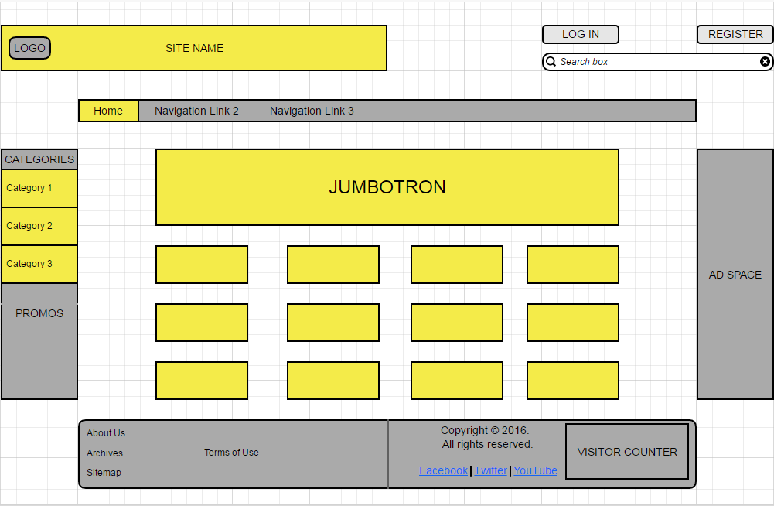

Figure 1.0 *index.html*

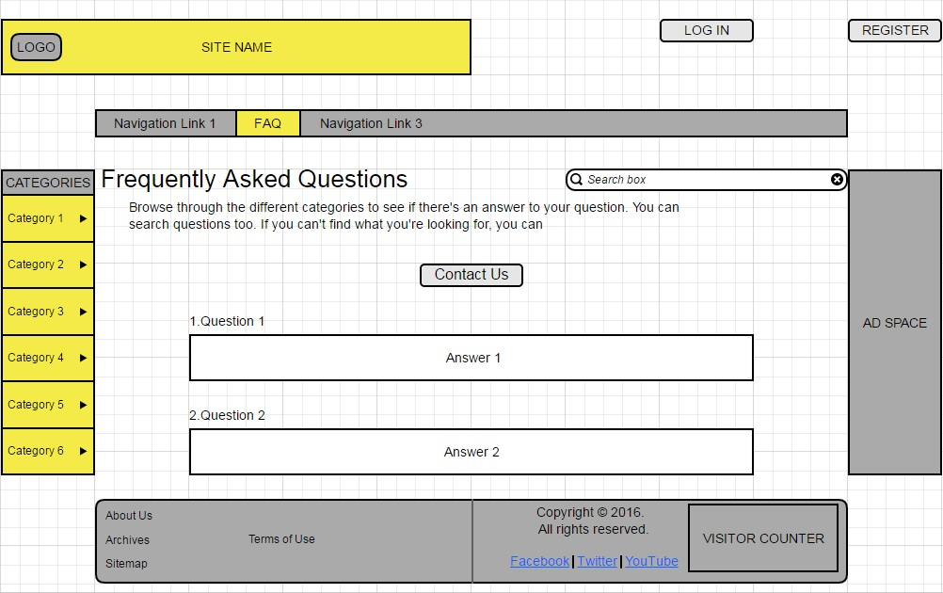

Figure 2.0 *faq.html*

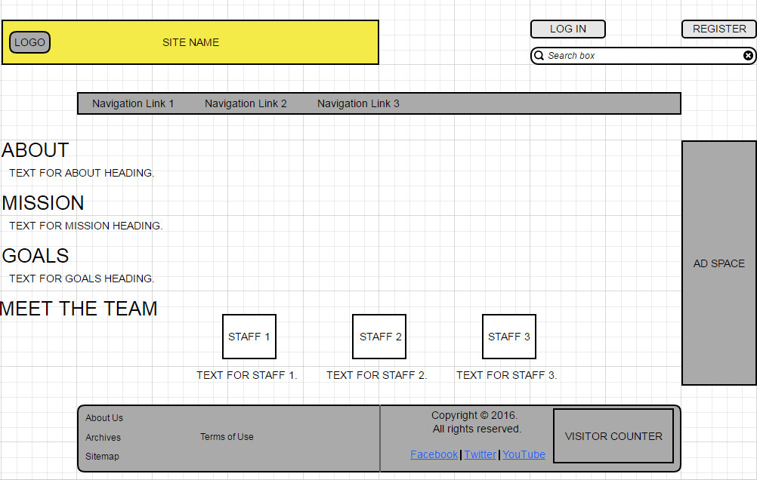

Figure 3.0 *about.html*

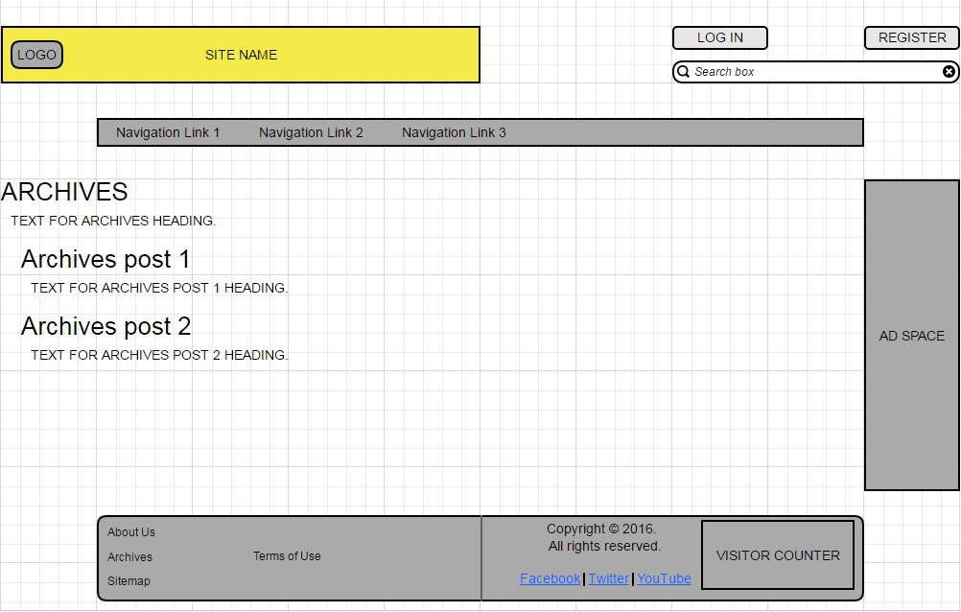

Figure 4.0 *archives.html*

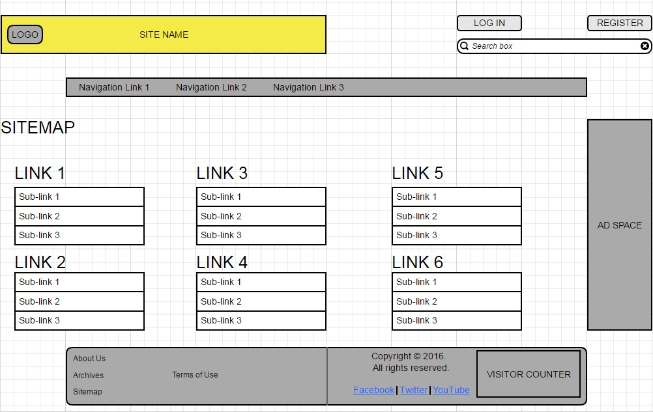

Figure 5.0 *sitemap.html*

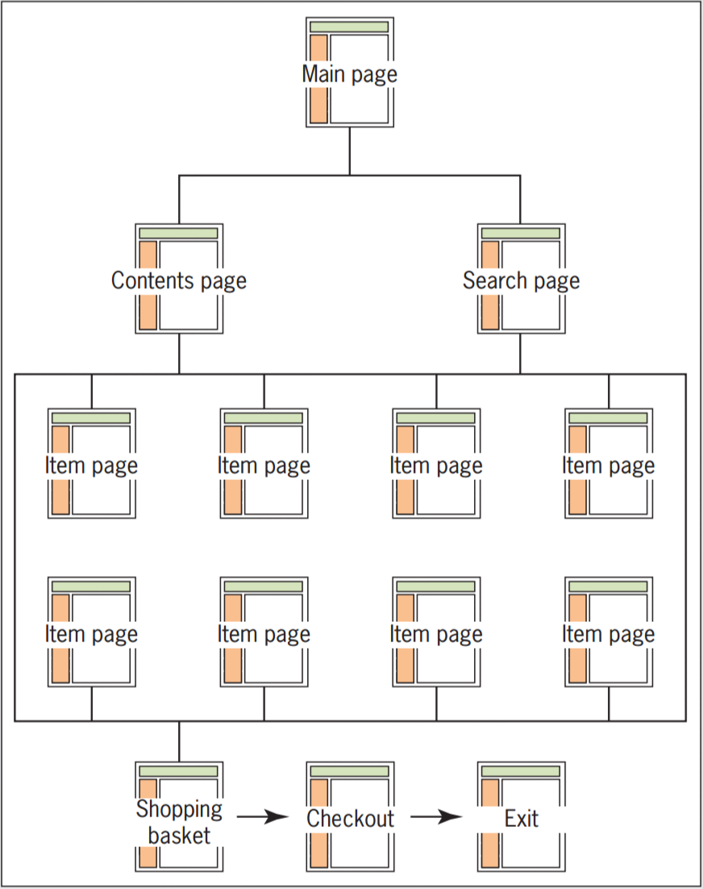

Figure 6.0 *Catalog structure*